

**YEAR: 7**

**2018**

**SUBJECT: Science**

**TEST: Classification**

**TIME: 50 minutes**

**QUESTIONS: 10 Multiple Choice (10 marks)**

**5 Short Answer (26 marks)**

**TOTAL MARKS: 36 marks**

**DO NOT WRITE ON OR MARK THIS PAPER**

**Part A: Multiple Choice Questions (10 marks)**

**Indicate Answer on Answer Sheet.**

1) State the type of scientist who names and classifies things.

a. Ecologist

b. Biologist

c. Taxonomist

d.Zoologist

2) Scientists classify organisms because:

a. it makes it easier to identify organisms.

b. there are only a few organisms that differ from each other.

c. most discoveries in biology have already been made.

d. all organisms have characteristics in common.

3) Organisms can be grouped into five major kingdoms. These are:

a. mammals, fish, birds, amphibians and reptiles.

b. animals, fungi, monera, plants and protists.

c. animals, fungi, insects, plants and algae.

d. animals, plants, insects, birds and reptiles.

4) Kingdoms themselves can be sub-divided. The sequence of classification following kingdoms is:

a. species, phylum, class, order, family, genus.

b. class, order, family, genus, species, phylum.

c. order, family, genus, phylum, class, species.

d. phylum, class, order, family, genus, species.

5) A vertebrate is an animal which has:

a. a backbone.

b. a hard shell.

c. wings.

d. fins

6) The reason for using structural characteristics (rather than colour or size) for classification is:

a. structural features are easy to observe.

b. individuals of the same type can differ in colour.

c. organisms change size as they grow.

d. all of the above.

**The diagram shows four characters, and a key to identify them.**

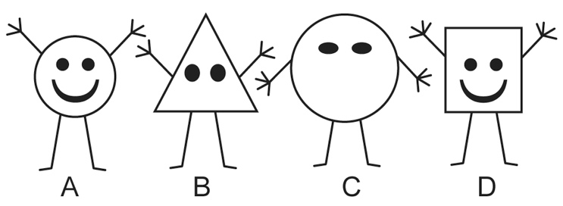

1 Round body Go to 3.

Not round body Go to 2.

2 Three fingers Gertie

Four fingers Iris

3 Mouth Fred

No mouth Harry

7) Which one is Iris?

a. A

b. B

c. C

d. D

8) Use the circular key below to **classify** an animal with 6 legs, 4 heads, 8 eyes and no mouth.

1. 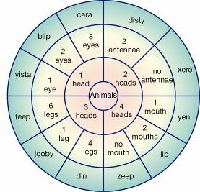
2. a. Feep
3. b. Xero
4. c. Cara
5. d. Zeep

9) Look at the four sea animals below:

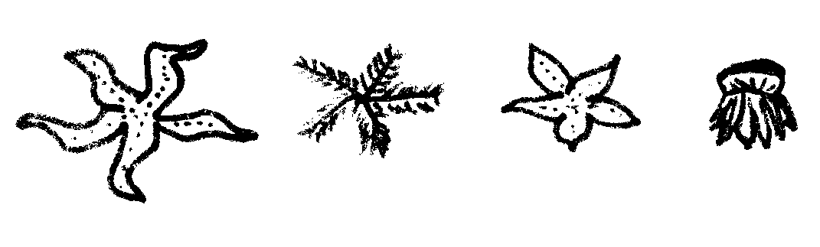

D

C

B

A

If three (3) of these animals were to be placed in one group and the remaining one in a separate group, which one would be in a group by itself?

1. A
2. B
3. C
4. D

10) Students created this key for their group.

1a Male Go to 2

b Female Go to 5

2a Straight hair Go to 3

b Curly hair Go to 4

3a Can roll tongue Mark

b Cannot roll tongue Yasu

4a Brown eyes Hans

b Grey eyes Jack

5a Straight hair Jane

b Curly hair Mai

**Identify** the description of Jack.

a) Straight-haired male with brown eyes that cannot role his tongue.

b) Curly-haired male with grey eyes.

c) Male that can roll his tongue and has grey eyes and curly hair.

d)Male with straight hair and brown eyes.



**SEMESTER TWO 2018**

**Classification Science Test:**

**ANSWER BOOKLET**

**NAME:**

**FORM:** **DATE:**

Multiple Choice Short Answer Total

**/26**

**/10**

**/36**

**SECTION ONE:** Multiple choice answers

Cross (X) through the correct answer.

|  |  |  |  |  |
| --- | --- | --- | --- | --- |
| **1** | a | b | c | d |
| **2** | a | b | c | d |
| **3** | a | b | c | d |
| **4** | a | b | c | d |
| **5** | a | b | c | d |
| **6** | a | b | c | d |
| **7** | a | b | c | d |
| **8** | a | b | c | d |
| **9** | a | b | c | d |
| **10** | a | b | c | d |

**Part B: Short Answer Questions (26 marks)**

**Answer in the spaces provided.**

1. A round dark coloured blob was discovered in a rock pool. **List** and **explain** 3 factors or observations which would help decide if it was living or non-living.

(6 marks)

1. List ( provide name of factor) ____________________________________________________________

Explanation/Meaning: __________________________________________________________________________________________________

__________________________________________________________________________________________________

b. List ( provide name of factor) _____________________________________________________________

Explanation/Meaning: __________________________________________________________________________________________________

__________________________________________________________________________________________________

c. List ( provide name of factor) _____________________________________________________________

Explanation/Meaning: __________________________________________________________________________________________________

__________________________________________________________________________________________________

If you decided it was living, what would you need to know to decide whether it was a plant or an animal?

(1 mark)

__________________________________________________________________________________________________

__________________________________________________________________________________________________

2) The dichotomous key below shows one way of presenting information on the plant

kingdom. Use the key to answer the questions that follow.

Plant Kingdom

No stem, Simple roots

Stem present

No seeds

Has seeds

Flowers

No flowers

Mosses and liverworts

Ferns

Flowering plants

Conifers

1. List one similarity and one difference between flowering plants and conifers

(2 marks)

Similarity

_______________________________________________________________________________

Difference

_______________________________________________________________________________

3) Use the key below to classify the animals pictured here. (4 marks)

**KEY ANIMAL**

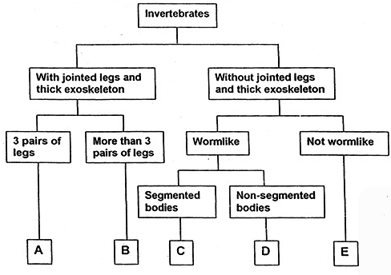

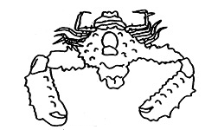

**I**

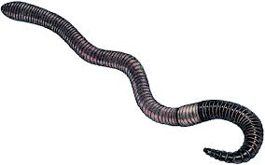

**II**

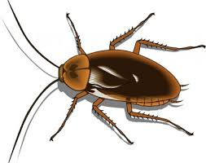

**III**

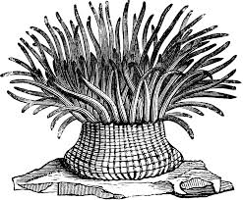

**IV**

|  |  |
| --- | --- |
| **ANIMAL** | **GROUP (A,B,C,D or E)** |
| **I** |  |
| **II** |  |
| **III** |  |
| **IV** |  |

4) Using the 3 creatures below, design a Dichotomous key (minimum of 3 steps)

to help identify them based on 2 or more specific characteristics. (3marks)

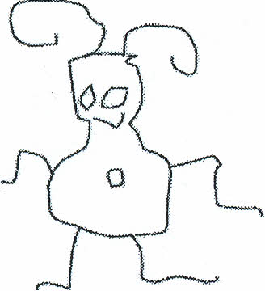

GLOP

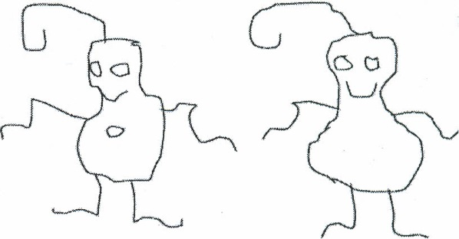

BIP

GLIP

5) Use the key to identify the species name of each of the smileys below then write their  
 name under the correct picture. The first one is done for you. (10 marks)

1. Teeth visible go to 2

Teeth not visible........... go to 4

2. Has a wide, toothy smile ……...*Smilus   
toothyus.*

Is not smiling ...go to 3

3. Visibly crying *Smilus dramaticus*

.... Frowning ..... *Smilus upsettus*

4. Eyes are symmetrical………….go to 5

Eyes not symmetrical …….. ….go to 8

5. Eyes shaped like hearts *Smilus valentinus* Eyes are shaped as ovals …… go to 6

6. Smiling, happy face *Smilus traditionalis.*

Not happy, frowning or other .... go to 7

7. Mouth curved down, frowning ...*Smilus saddus*

Mouth is a small circle. ……….*Smilus suprisus*

8. Has a pirate eye patch………..*Smilus piratus*

Does not have eye patch……..go to 9

9. One eye is much larger than the   
other eye ………………………….*Smilus mutatus*

One eye is winking …….*Smilus winkus*

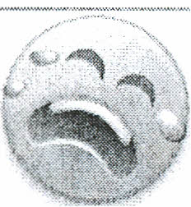

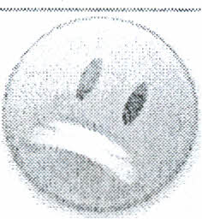





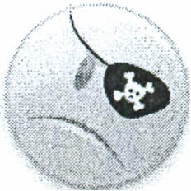

S.dramaticus

